Twentieth Sunday after Pentecost
October 11, 2026

Gathering

Welcome & Announcements
Prelude

Confession and Forgiveness
In the name of the Father, and of the Son, and of the Holy Spirit.
Amen.
Almighty God, to whom all hearts are open, all desires known, and from whom no secrets are hid: Cleanse the… through Jesus Christ our Lord.
Amen
If we say we have no sin… cleanse us from all unrighteousness.
Most merciful God,
We confess that we are slaves to sin and cannot free ourselves. We have sinned against you in thought, word, and deed, by what we have done and by what we have left undone. On account of your great mercy, through your Son Jesus Christ, we pray that you would free us from ourselves, so that we may trust in your promise and obey your commandments, to the glory of your holy name. Amen.
Absolution -
Almighty God in His mercy…… children of God and bestows on them the Holy Spirit. Amen.

Gathering Hymn ELW #

L: The grace of our Lord Jesus Christ, the love of God, and the communion of the Holy Spirit be with you all.
C: And also with you.
L:The LORD is my shepherd, I shall not want.
C: He makes me lie down in green pastures; he leads me beside still waters;
L: he restores my soul. He leads me in right paths for his name’s sake.
C: Even though I walk through the valley of the shadow of death, I fear no evil; for you are with me; your rod and your staff—they comfort me.
L: You prepare a table before me in the presence of my enemies; you anoint my head with oil; my cup overflows.
C Surely goodness and mercy shall follow me all the days of my life, and I shall dwell in the house of the LORD forever.

Psalm 23:1-6

Praise Hymn ELW #
Greeting and Prayer of the Day
O Lord,
sustain your Church with your perpetual mercy. Without you, in our weakness we will surely fail. Therefore, keep us ever by your help from all things hurtful, and lead us to all things profitable to our salvation; through your Son, Jesus Christ, our Lord, who lives and reigns with you and the Holy Spirit, one God, now and forever. Amen
Word
Children’s Time
First Reading Isaiah 25:6-9 OT p. 723
Second Reading Philippians 4:4-13 NT p.212
Gospel Verse ELW #
Gospel Matthew 22:1-14 NT p. 24-25
Sermon Keep it Simple Saint: Invited
Hymn of the Day ELW #
Apostle’s Creed ELW p.105
Prayers L:God of grace. All: Hear our prayer.
Lord’s Prayer
Sharing of the Peace
The peace of Christ be with you always! And also with you.
Thanksgiving
Gathering of Offerings (including change for our mission church)
Offertory Hymn ELW #
Offertory Prayer
P: Let us pray. Merciful Father,
C: we offer with joy and thanksgiving what you have first
given us—our selves, our time, and our possessions, signs of
your gracious love. Receive them for the sake of him who
offered himself for us, Jesus Christ our Lord. Amen
Sending
Benediction
Sending Hymn ELW #
Dismissal Go in peace. Live by the Spirit All: Thanks be to God!

Flowers: Keith & Carol Larson Anniversary
Preacher: Pastor Carl Billings
Musician: Carol Kelm
Ushers: Mastbergen Family
Altar Guild: April Goodwin & Gloria Hill SS Teacher : Joe Krizan
This Week at Holy Cross
Today 9:00 am — Worship
10:10 am — Fellowship (WOW Serving)

Monday 11:00 am — Bible Study at Havenwood
Noon – 6:00 pm Blood Mobile sponsored by St Johns
6:00 pm — Resources Meeting
7:00 pm — Council Meeting

Tuesday 6:30 pm —Threads of God’s Love

Wednesday 3:00 pm --- Confirmation to Feed My Starving Children
6:45 pm — Mid Week Worship w/Bruce Kelm

Friday 9:30 am — Friday Morning Coffee

Saturday :30-4:30 – Building Rental – Marigold Quilt Class

Next Sunday,
October 18th 9:00 am — Worship & Sunday School
w/ Pastor Myke Main
10:10 am — Fellowship (Krizan Family Serving)

Feed My Starving Children – Service Event
Wednesday October 14 @3:00 pm. See kiosk for details

Annual Fall Supper – Wednesday October 21st 4:30-7:00 pm
Come and enjoy all your Fall Supper favorites and time of fellowship.

Confirmation Sunday – Sunday October 25th at 9:00 am.

Newsletter Article Deadline – Articles for the October Newsletter will be due by Wednesday October 21st .

Blood Mobile – Monday October 12th the Blood Mobile will be at Holy Cross. Sponsored by St John’s.
Sign up to donate blood at www.redcrossblood.org.

Pastor Carl Billings in Glenwood City –
Tuesday– Afternoon – evening, & Wednesday all day
Thursday – Morning, Sunday – Morning

Wanda will be in the office Monday-Thursday 9-3.
GIVING with
VANCO

Holy Cross Lutheran Church
615 Maple Street, PO Box 65, Glenwood City, WI 54013
(715) 265-4411 gcHolyCross@cltcomm.net gcholycross.org
Intentional Interim Pastor Carl Billings
Phone: (763) 360-7126 Email: carlbillings@me.com

October 11, 2026
Twentieth Sunday after Pentecost

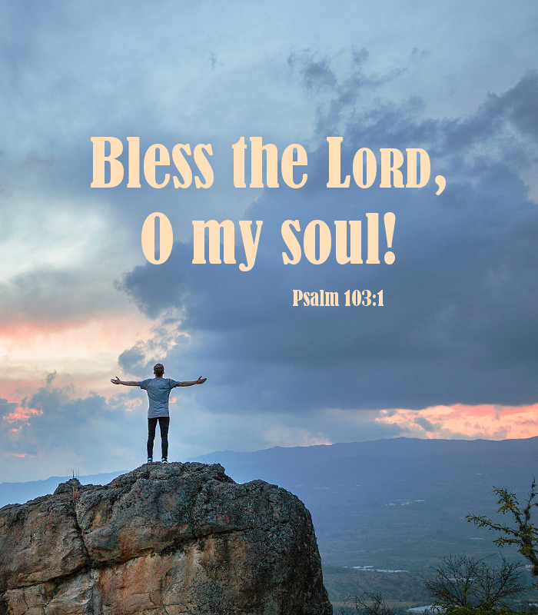

Holy Cross Lutheran Church

Called by the Holy Spirit
to Come
to Grow
to Live
as Disciples of Jesus Christ

