Eleventh Sunday after Pentecost
August 9, 2026

Gathering

Welcome & Announcements
Prelude

Confession and Forgiveness
In the name of the Father, and of the Son, and of the Holy Spirit.
Amen.
Almighty God, to whom all hearts are open, all desires known, and from whom no secrets are hid: Cleanse the thoughts of our hearts by the inspiration of your Holy Spirit, that we may perfectly love you and worthily magnify your holy name, through Jesus Christ our Lord.
Amen
If we say we have no sin… cleanse us from all unrighteousness.
Most merciful God,
We confess that we are slaves to sin and cannot free ourselves. We have sinned against you in thought, word, and deed, by what we have done and by what we have left undone. On account of your great mercy, through your Son Jesus Christ, we pray that you would free us from ourselves, so that we may trust in your promise and obey your commandments, to the glory of your holy name. Amen.
Absolution -
Almighty God in His mercy…… children of God and bestows on them the Holy Spirit. Amen.

Gathering Hymn What a Fellowship, What a Joy Divine ELW #774

L: The grace of our Lord Jesus Christ, the love of God, and the communion of the Holy Spirit be with you all.
C: And also with you.
P: I love you, O LORD, my strength.
C: The LORD is my rock, my fortress, and my deliverer,
P: my God, my rock in whom I take refuge,
C: my shield, and the horn of my salvation, my stronghold.
P: I call upon the LORD, who is worthy to be praised,
C: so I shall be saved from my enemies.

Psalm 18:1-3

Praise Hymn My Life Flows On in Endless Song ELW #763

Greeting and Prayer of the Day
Almighty and merciful God,
only by your gift of grace can the faithful offer service that is worthy of you and deserving of praise. Keep us from stumbling as we run to receive your promises; through Jesus Christ, your Son, our Lord, who lives and reigns with you and the Holy Spirit, one God, now and forever. Amen
Word
First Reading Job 38:4-18 OT p. 533-534
Second Reading Romans 10:5-17 NT p.167
Gospel Verse Gospel Acclamation - Celtic Alleluia ELW #174
Gospel Matthew 14:22-33 NT p. 16
Children’s Time
Sermon Heart of the Gospel: Happy Feet
Hymn of the Day Let Us Ever Walk with Jesus ELW #802
Apostle’s Creed ELW p.105
Prayers L:God of grace. All: Hear our prayer.
Lord’s Prayer
Sharing of the Peace
The peace of Christ be with you always! And also with you.
Thanksgiving
Gathering of Offerings (including change for our mission church)
Offertory Hymn We Give Thee but Thine Own ELW #686 vs. 1 & 2
Offertory Prayer
P: Let us pray. Merciful Father,
C: we offer with joy and thanksgiving what you have first
given us—our selves, our time, and our possessions, signs of
your gracious love. Receive them for the sake of him who
offered himself for us, Jesus Christ our Lord. Amen
Sending
Benediction
Sending Hymn Precious Lord, Take My Hand ELW #773
Dismissal Go in peace. Serve the Lord. All: Thanks be to God!

Flowers today from Velma Crosby IMO Robert Crosby Sr.
Preacher: Pastor Carl Billings
Musician: Carol Kelm
Ushers: Ned Hahn
Altar Guild: Joan Bartz
This Week at Holy Cross
Today 9:00 am — Worship
10:10 am — Fellowship (WOW Serving)

Monday 11:00 am — Bible Study at Havenwood
Noon – 6:00 pm – Blood Mobile at Holy Cross
4:00 pm — Sundaes on Mondays 4-4:30
6:00 pm — Resources Meeting
7:00 pm — Council Meeting

Tuesday 6:00 pm — Threads of God’s Love

Thursday 10:30 am — Glenhaven Worship

Next Sunday,
August 16th 9:00 am — Worship
10:10 am — Fellowship (Mastbergen Family Serving)

Blood Mobile – Monday August 10th the Blood Mobile will be at Holy Cross. Sign up sheet for volunteer workers is on the kiosk in the lobby.
Sign up to donate blood at www.redcrossblood.org.

Outdoor Worship & Blessing of the Backpacks – Sunday August 23rd we will be worshiping outdoors at Himan Park. We will also be doing Blessing of the Backpacks so have the kids bring their backpacks.

LCMC Annual Gathering – October 4-7, 2026. Lutheran Church of Hope in West Des Moines IA. Visit www.lcmc.net for more details.

Prayer Request/Connection Card—Please find green Connection Card/Prayer Request cards in the pews in front of the bibles.
Please fill out as needed and place in collection plate.

Newsletter Article Deadline – Articles for the Sept Newsletter will be due by Wednesday August 19th.

Pastor Carl Billings in Glenwood City –
Tuesday– Afternoon – evening, & Wednesday all day
Thursday – Morning, Sunday – Morning

Wanda will be in the office Monday-Thursday 9-3.
GIVING with
VANCO

Holy Cross Lutheran Church
615 Maple Street, PO Box 65, Glenwood City, WI 54013
(715) 265-4411 gcHolyCross@cltcomm.net gcholycross.org
Intentional Interim Pastor Carl Billings
Phone: (763) 360-7126 Email: carlbillings@me.com

August 9, 2026
Eleventh Sunday after Pentecost

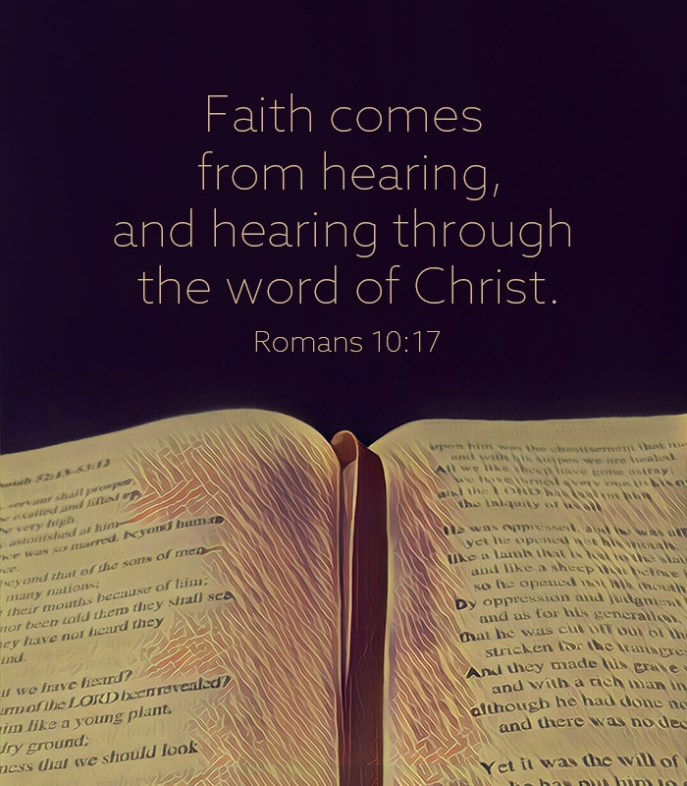

Holy Cross Lutheran Church

Called by the Holy Spirit
to Come
to Grow
to Live
as Disciples of Jesus Christ

