JOIN US AS WE BUILD A HOME
FOR A NEEDY FAMILY IN
SAN RAYMUNDO GUATEMALA
JANUARY 17th-23rd 2027 THROUGH
CASAS POR CRISTO
(HOUSES FOR CHRIST)

We plan to build a home with 3 rooms and a large front porch from start to finish in three days and have two days to explore Guatemala and help at Ceiba Vida’s Girls School – Liberty Christian Academy. The total cost for building materials for the home is $12,425.

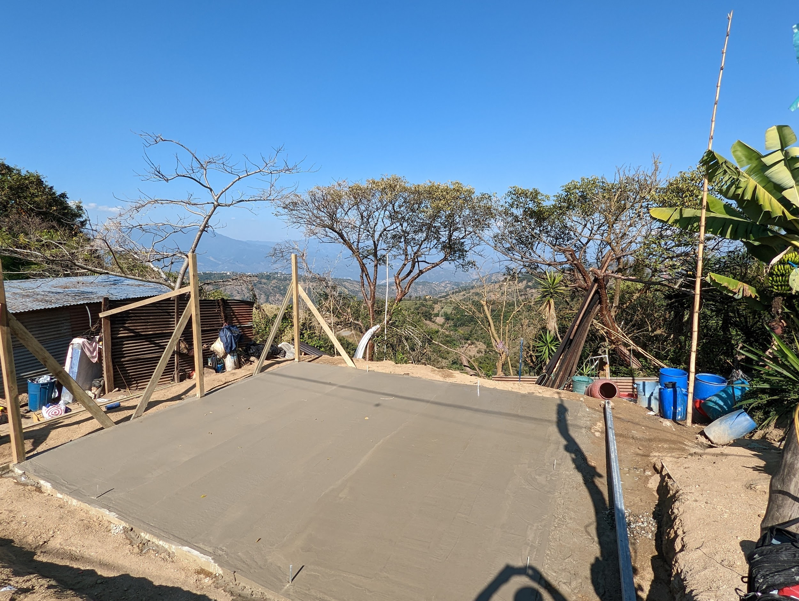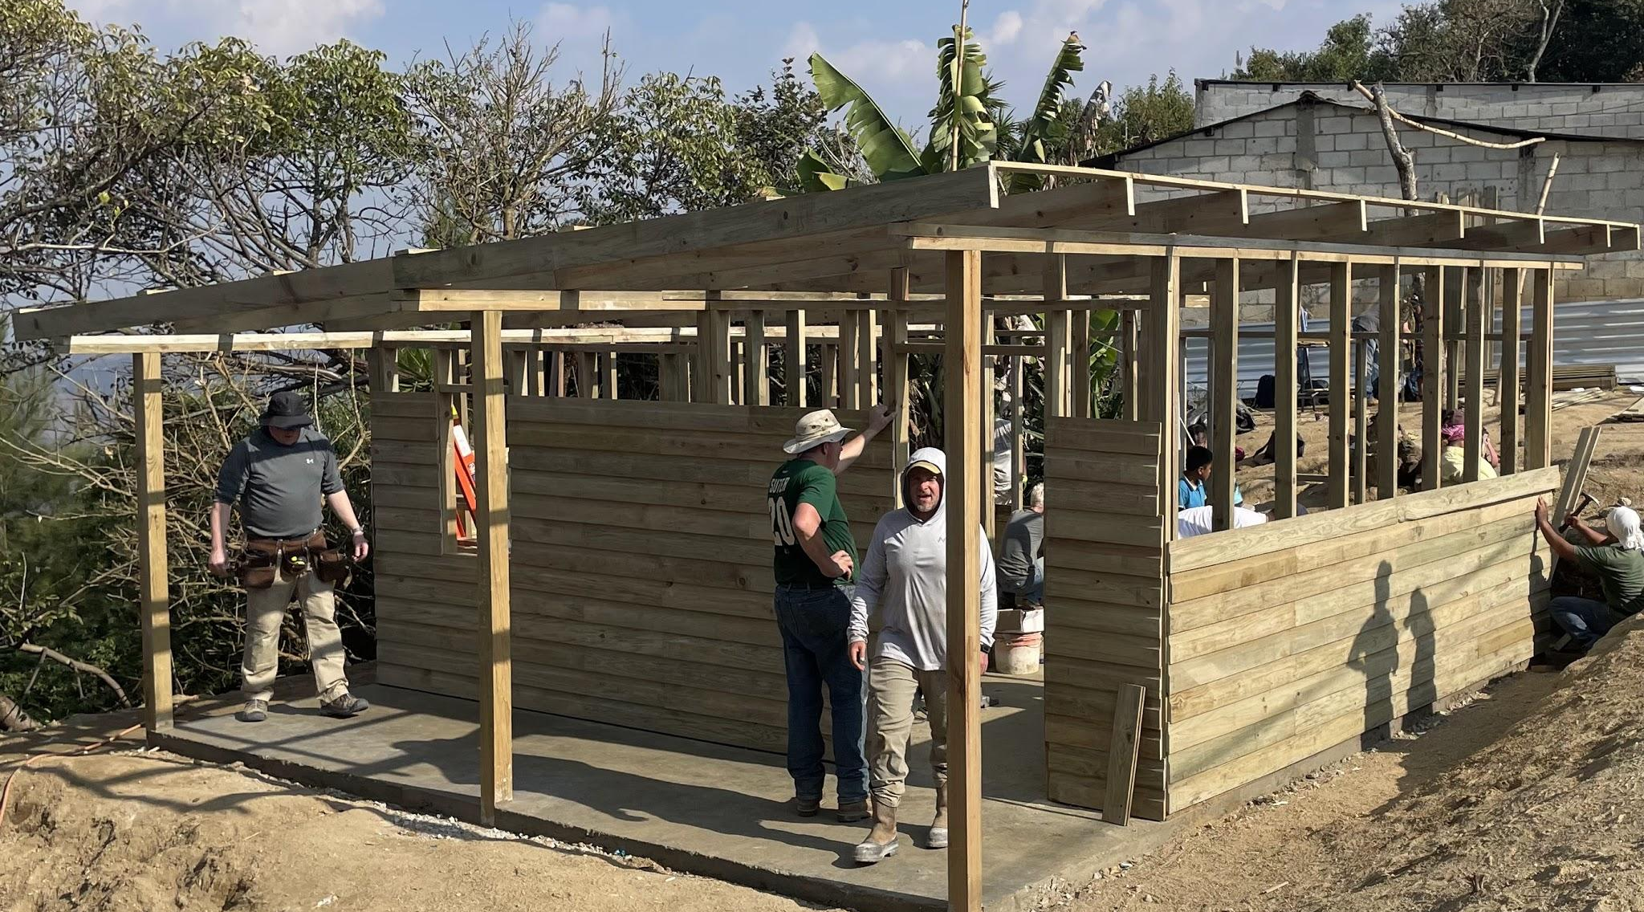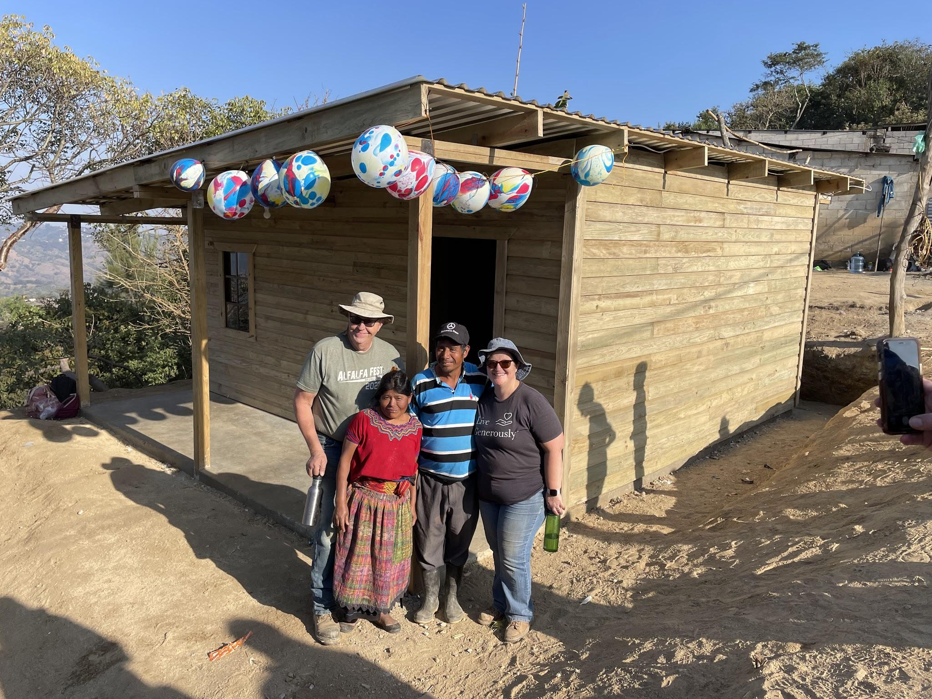

Consider joining our build team for a vacation with a purpose! We have 14 on our team and our goal is 18-20 people. The cost is $360 for meals, lodging and in country transportation and $1,125.33 for airfare for a total trip cost of $1,485.33 per person. Commitments are needed by October 1st with deposit of $360. Airfare is due by November 18th. We would love to have you join us!

If you would like to donate toward building materials, checks can be made payable to Holy Cross - Casas por Cristo. Thanks for your generosity! For more information, call Joan at 715-607-0030.

